CHAPTER 14
PERIODIC MOTION
Discussion Questions
Q14.1 The object travels a total distance of 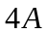 in one period. If the amplitude is doubled then this distance doubles. The period does not depend on the amplitude so is unchanged. The maximum speed is given by Eq.(14.23) and doubles when the amplitude doubles. The distance traveled in one cycle doubles but the speed increases just enough to keep the time for one cycle the same.

Q14.2 Swinging of a playground swing; this motion is simple harmonic only for small amplitudes and the motion also loses mechanical energy due to dissipative forces. Pistons in a car engine; force doesn’t precisely obey Hooke’s law.

Q14.3 Yes. Period or frequency is independent of the amplitude. This is important; pitch generated needs to be independent of how hard the tuning fork is struck and needs not to change as vibrations die away.

Q14.4 (a) 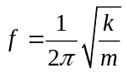. The frequency increases because the mass of the oscillating object decreases. (b) 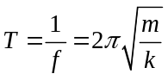. The period decreases. (c) The amplitude is given by 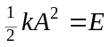, where E is the total energy of the system. When the box is at its maximum distance from the equilibrium point, 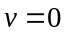 and all the energy of the system is stored as elastic potential energy in the stretched or compressed spring. Therefore, removing the pebble doesn’t alter the total energy of the system and the amplitude doesn’t change. (d) Since the total energy of the system doesn’t change, the maximum kinetic energy of the box doesn’t change. (e) 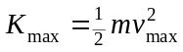, where 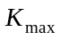 is the maximum kinetic energy of the box and 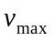 is its maximum speed. doesn’t change but m is decreased, so increases.

Q14.5 The half spring stretches half as much as the full spring for the same applied force, since it has half the number of coils. 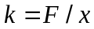 so the force constant of each half is twice that of the full spring. 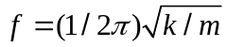 so the frequency would be larger by .

Q14.6 There is no horizontal force on the coin other than the static friction force exerted on it by the glider surface. Since the coin isn’t slipping relative to the glider, the static friction force on the coin must give the coin the same horizontal acceleration as the acceleration of the glider. The acceleration of the glider is greatest at the end points of its motion, when it is its maximum distance from its equilibrium position and this is where the static friction force on the coin is the greatest. The acceleration of the glider is zero as it moves through its equilibrium position, and at this point in the motion the static friction force on the coin is zero.

Q14.7 Yes, the center of mass of the system, at the center of the spring, remains at rest just as if that point were attached to a stationary object. The motion is that of a glider attached to a half-spring. The half-spring has twice the force constant of the full spring, so the period is smaller by a factor of 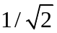 when two gliders are used compared to where there is only one glider and the other end of the spring is kept stationary.

Q14.8 Use the chain and ring to construct a simple pendulum. Measure the period of the pendulum and use 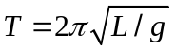 to calculate . You will need to estimate the length of the pendulum you have made. Using the data in Appendix F, 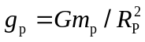 gives 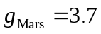 m/s. The difference between on Earth and Mars is large and the measurement of does not need to be very precise.

Q14.9 The period is the same in all three cases. Let 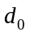 be the amount the spring is stretched when the acceleration of the object equals that of the elevator. Upward acceleration of the elevator requires that be larger than when the elevator is at rest or moving with constant velocity and downward acceleration of the elevator decreases . But the net force on the object when it is displaced a distance x from the point is still given by 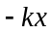 and the period is unaffected by the acceleration of the elevator. The acceleration of the elevator is equivalent to changing the value of g and it is shown in Section 14.4 that the period doesn’t depend on g for vertical SHM.

Q14.10 Both the pendulum and the space station would be in free-fall, with the net force on each being gravity. The pendulum would no longer swing back and forth when displaced and released. The period of the object on the spring depends on the force constant of the spring and the mass of the object and would be unchanged.

Q14.11 (a) For a pendulum 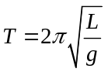. An upward acceleration a is equivalent to increasing g to 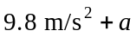 . The restoring force is increased and the period decreases. (b) Motion with constant velocity cannot be distinguished from the elevator being at rest. The period is unchanged. (c) A downward acceleration a decreasing g to 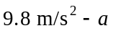 . The restoring force is decreased as the period decreases. (d) The elevator is in free-fall and the pendulum ceases to swing back and forth. There is no restoring force and the period becomes infinite.
Q14.12 (a) 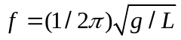. To double the frequency decrease the length by a factor of 4. (b) . To double the period increase the length by a factor of 4. (c) 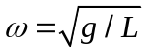 so decrease the length by a factor of 4, just as in part (a).
Q14.13 decreases with altitude so the period of the pendulum increases and the clock loses time.

Q14.14 The period of a simple pendulum is independent of the amplitude; so long as the amplitude remains small the period remains the same. When the amplitude is increased the distance traveled in one period is greater. But the restoring force also increases with the angular displacement from equilibrium so the mass moves faster. The two effects compensate and the period is independent of amplitude. The same reasoning and conclusion applies to a physical pendulum. But for larger amplitudes the restoring force is no longer proportional to the displacement and the motion ceases to be simple harmonic. As Figure 14.22 shows, the magnitude of the restoring force is less than proportional to the displacement. A smaller restoring force means a longer period; the period increases when the amplitude decreases. The same reasoning and conclusion applies to a physical pendulum.

Q14.15 The period of oscillation of the shorter leg, treated as a physical pendulum, is less. It is easiest for the dog to walk when its legs swing at their natural frequency, as discussed in Example 14.10.

Q14.16 The tension is in the radial direction. The pendulum mass has a radial acceleration 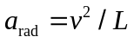, directed inward. At the end points of the motion, where 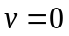 and the string makes an angle 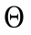 with respect to the vertical, 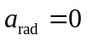 and 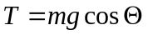. As the string moves through the vertical position the speed of the mass is a maximum and 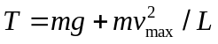. The tension is greater when the string is vertical and is least at the end points.

Q14.17 Yes, such a standard could be used. An advantage is that such a standard is easily reproduced and easy to use. Disadvantages are that it is difficult to measure the period to high accuracy and that the period varies with location, due to variations in .

Q14.18 The angular frequency is equal to 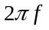, where 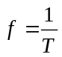 is the frequency of oscillation of the pendulum. 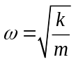 so for a given mass and spring, is a constant and doesn’t vary during the motion. The angular speed 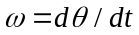 is the rate at which the angular displacement of the pendulum is changing. It is equal to 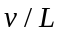, where v is the speed of the pendulum bob and L is the length of the pendulum. The linear speed v is continually changing during the motion so this is also changing. is zero when the pendulum is at its maximum angular displacement and is a maximum when the pendulum is swinging through its equilibrium position, when it is vertical.

Q14.19 The structures should not have natural frequencies in the range of typical earthquake frequencies, to avoid resonance excitation of the frequencies of motion of the structures. Damping should be large so that large amplitude oscillations don’t build up.

